**Assignment 2**

1. Oracle SQL developer connection

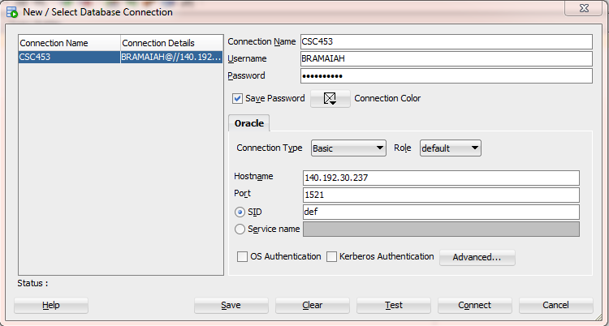

2. Box Office Mojo Query results

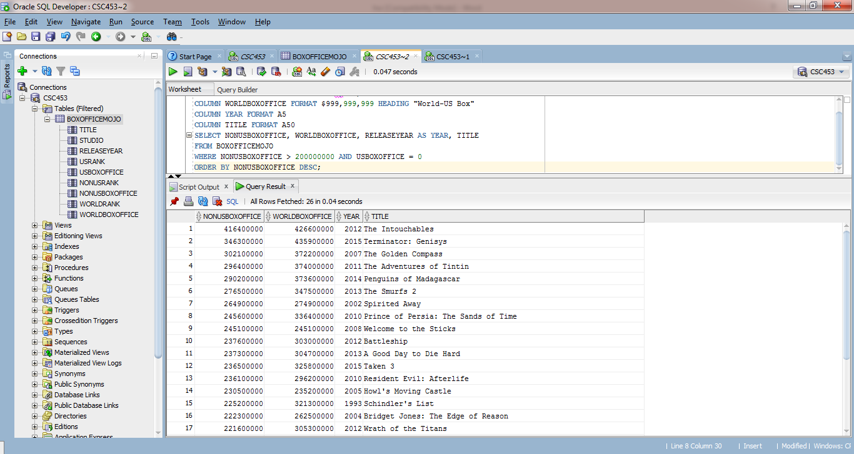

1. Entity – Relationship diagram

